Questions and answers part 3

1.What is the expected fire load density in laboratory buildings?

The fire load density will be the result of the activities conducted by Ł-PIT. Taking into account that the exact division of the area is not known today, please (based on the activity profile of Ł-PIT and standards) select and adopt one average indicator for the entire laboratory part.

2. The competition guidelines state that each laboratory segment must have a maneuvering area and access for trucks. Do these guidelines also apply to the laboratory hall for rail vehicles and, if so, is it enough to provide only 1-2 stations (for example from the orange side - drawing in the attached file) or is it possible to service more vehicles at the same time and it will be necessary to place these stations on the blue side (see picture)? If more positions are required, please specify their number.

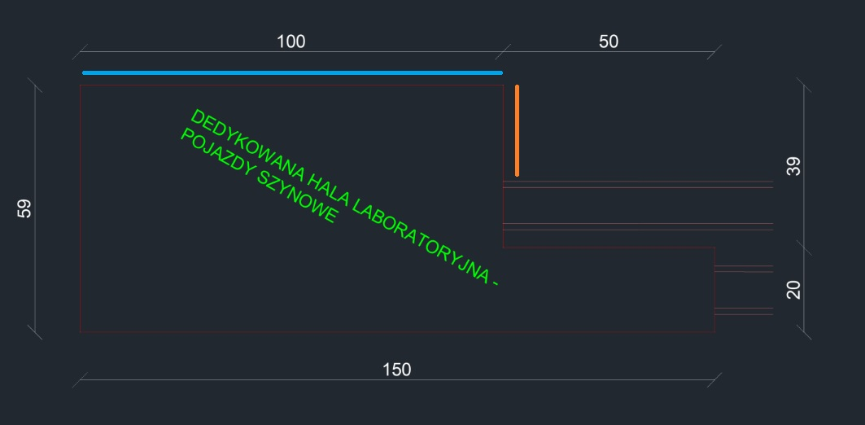

The entrance to the railway hall can and should be in the same places where the tracks will "enter" the building. We plan to keep the railhead level at ground level (we avoid limiting the use of the remaining part of the property).

